Hi Guys,

Some notes if you or an end-user receive the following error message trying to access the SSRS web url:

|  |  |
| --- | --- |
| |  | | --- | | The report server installation is not initialized. (rsReportServerNotActivated) (rsRPCError) | |

* Navigate to the reporting server in question
* Open Reporting Services Configuration Manager
* Navigate to Encryption Keys on the left hand menu

It should look like the following:

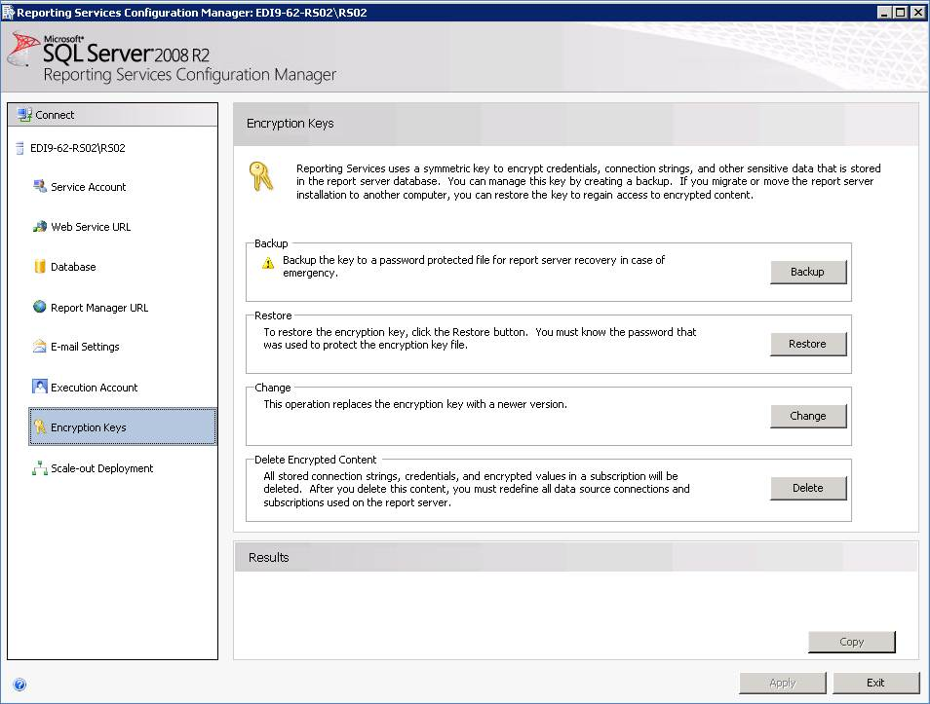

If you find that the Backup and Change options on the right are greyed out, There’s a problem.

The lack of these options means that the Encryption Key within the report server database has become corrupt and can no longer use all of the content within it.

This key holds encrypted data such as connection strings to the databases and the service account details (and passwords) for the service accounts used to access the database + the report server.

A bit of background on Reporting Services: The Encryption Key is created during the SSRS installation and contains various information including the Service Account information and password entered during the installation, without re-setting the Encryption keys this cannot be changed.

Please be aware that deleting the Encryption Key will remove all connection strings and service account information from reports and datasources, once it has been deleted you cannot get this back without re-entering the information manually.  This option should only be used as a last resort if Reporting Services becomes corrupt.

I googled the problem to death the last time Hobbycraft had this problem and it appears to be a known/common problem with SSRS and Encyption Keys.

After the Encryption keys have been deleted all reports will still exist within Report Viewer and Report Manager. As subscriptions are set up on the server whoever created them saved them on, they will have to re-set up all of the subscription timings etc themselves.

To help the end user out (or do it yourself with a Webex if they really don’t want to) you can use the attached script which gives you Report Names + the Last subscription run time. From this you can see what the previous schedule was to recreate the subscriptions.

I’ve spoken to Sean earlier about potentially setting up a weekly task to backup the Encryption Key, however unfortunately this would have to be a manual process (although it would prevent having to do the above).

Regards,

**Jonathan Hall**  
**SQL DBA**  
K3 Managed Services  
K3 Business Technology Group  
Phone: 0844 254 0200 | Int: +44 (0) 131 248 3030

Mob: 07917709329  
Email: [jonathan.hall@k3btg.com](mailto:jonathan.hall@k3btg.com)  
Web:  [www.k3managedservices.com](http://www.k3managedservices.com/)

Support: [support@k3managedservices.com](mailto:support@k3managedservices.com)

[](http://www.k3managedservices.com/)